Google Play Store: Apps per Category Report and Analysis

1. Introduction

This report will include data and information regarding the Google Play Store and will be

used to answer a user story. The data utilized for answering the user story consists of

10,841 rows and 13 columns all related to Google Play Store statistics and metrics. These

ranged from the category of the app, the overall rating, installs, current version, price, and

other similar factors. Meaning there are 10,841 apps and relevant information contained

within the data. The question we are tasked with is, “User would like to know how many apps there are in certain categories ”. In this report, I will be discussing how I cleaned

the data to present a more clear picture as well as display the relevant data.

2. Data Cleaning

After loading the CSV file, I first wanted to see all the unique categories. I noticed there was a category named ‘1.9’ with only 1 value. It seems to be missed placed and so I moved it into a more suitable category and deleted 1.9. With all of the categories looking good, I removed all of them except: ‘ENTERTAINMENT’, ‘PRODUCTIVITY’, and ‘SOCIAL’. I then converted the ‘Price’ column from string to float to allow for mathematical manipulation.

3. Analysis

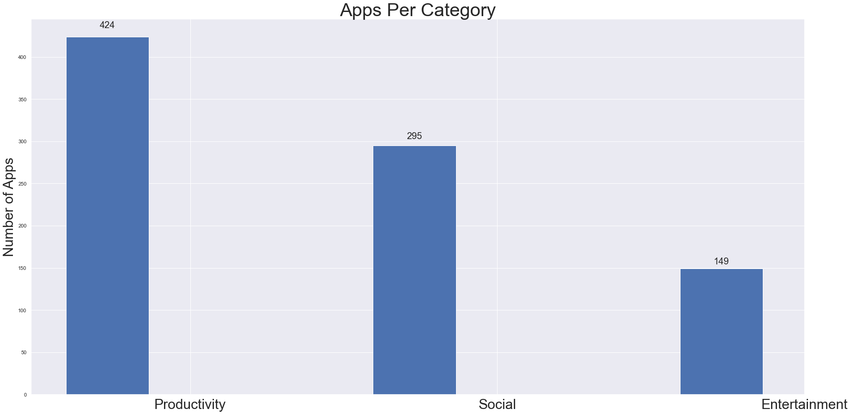

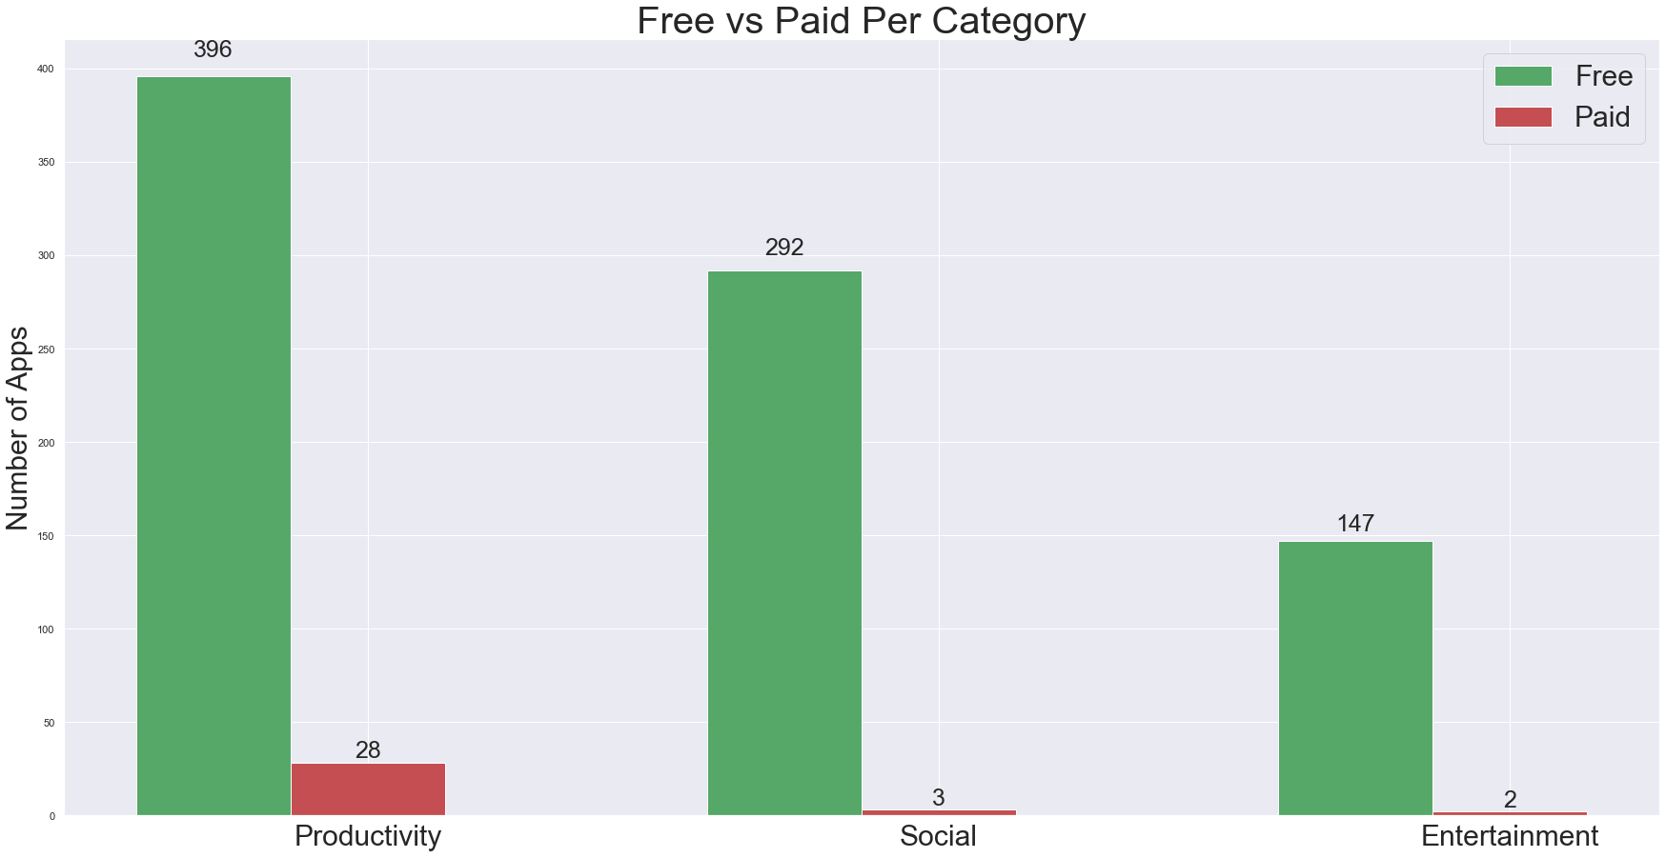

The below charts show the highest price in category, as well as the lowest price in the category.

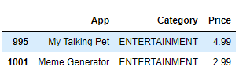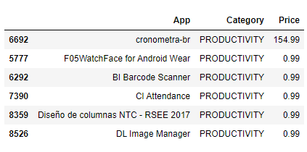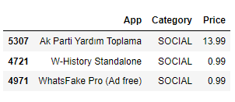

Below is listed the highest priced apps across all categories, as well as the cheapest priced apps.

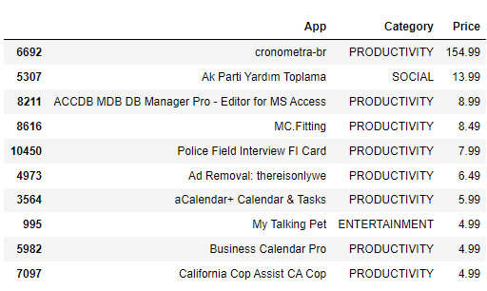

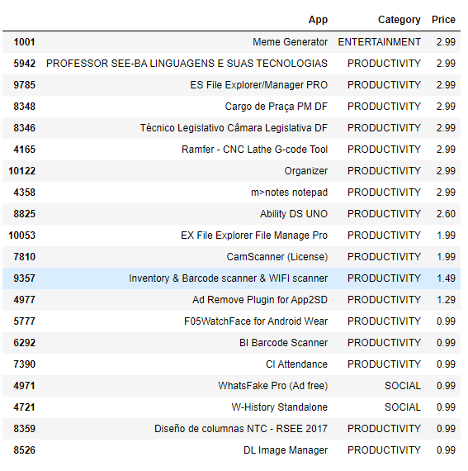

4. Conclusion

As we can see, the category ‘Productivity’ is by far the most dense category of apps. Everyone wants to be more productive. We can also see that most of the apps are free. In fact, only 33 of the 868 apps are paid for (4%). The mean price, of those apps that are NOT free, is $8.33. That is very skewed though because of the one app that costs $154.99. If we remove that outlier the mean price drops to $3.75. The mean ratio of paid apps to free apps per category is 3%. People usually don’t like to pay for apps unless the app is going to offer something that the free ones don’t.